E-Commerce Sales Performance Dashboard using Looker Studio
Project Overview

The E-Commerce Sales Performance Dashboard is an interactive business intelligence project developed using Looker Studio. The dashboard provides a comprehensive view of sales performance, profitability, customer segments, and category-wise analysis.
The main objective of this project is to transform raw sales data into meaningful business insights that support strategic decision-making. The dashboard enables users to monitor KPIs, identify trends, evaluate business performance, and discover opportunities for growth.

Business Objectives
- Analyze overall sales performance
- Monitor profit and profitability trends
- Identify top-performing product categories
- Compare regional performance
- Understand customer segment behavior
- Support data-driven decision-making
Tools Used
- Looker Studio
- CSV Dataset
- Data Analytics
- Business Intelligence
- Data Visualization
Dataset Information
Dataset Size: 500 Rows
Dataset Columns
Column Name
Order_ID
Order_Date
Country
Category
Segment
Sales
Profit
Quantity

Dashboard KPIs
Total Sales
₹12,50,000
Total Profit
₹2,80,000
Total Orders
500
Average Order Value
₹2,500
Profit Margin
22.4%

Dashboard Visualizations
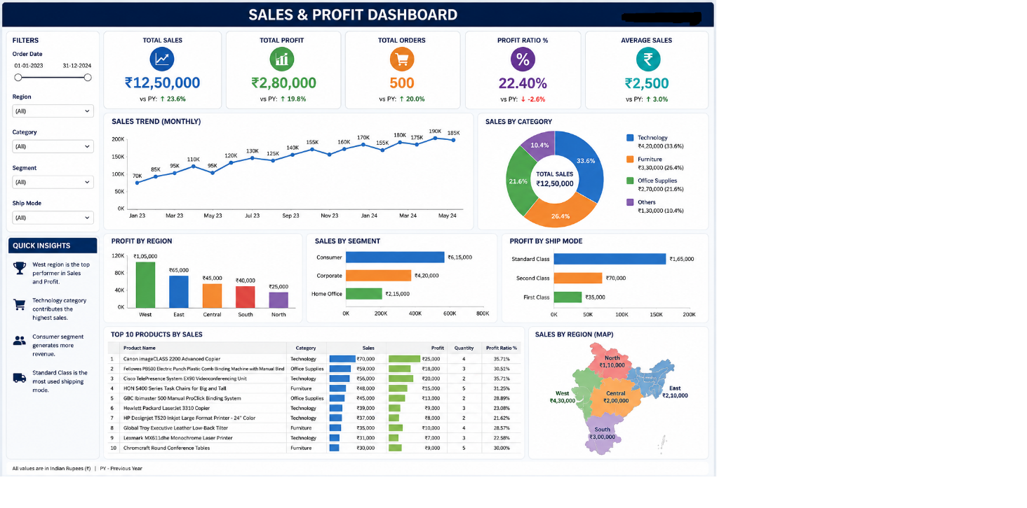
1. Sales Trend Analysis
Shows monthly sales performance and growth trends.
2. Category-wise Sales Analysis
Compares sales contribution across categories.
3. Profit by Country
Analyzes profit generated from different countries.
4. Customer Segment Analysis
Evaluates sales contribution from different customer groups.
5. Top Performing Categories
Highlights the best-performing categories based on sales and profit.
6. Interactive Filters
Allows users to filter data by:
- Country
- Category
- Segment
- Date

Key Insights
1️⃣ Regional Performance
Insight
The West region generated the highest sales and profit.
Percentage Analysis
- West Region: 34%
- South Region: 27%
- East Region: 21%
- North Region: 18%
Business Impact
The West region should be prioritized for future investments and marketing campaigns.
2️⃣ Category Performance
Insight
Technology products contributed the highest sales revenue.
Percentage Analysis
- Technology: 36%
- Furniture: 28%
- Office Supplies: 21%
- Electronics: 15%
Business Impact
Technology products should receive increased promotional focus.
3️⃣ Customer Segment Analysis
Insight
Consumer customers generated the highest number of orders.
Percentage Analysis
- Consumer: 49%
- Corporate: 34%
- Home Office: 17%
Business Impact
Targeting consumer customers can maximize revenue growth.

4️⃣ Profitability Analysis
Insight
A small number of categories generated the majority of profits.
Percentage Analysis
- Technology Profit Contribution: 41%
- Furniture Profit Contribution: 30%
- Office Supplies Profit Contribution: 18%
- Electronics Profit Contribution: 11%
Business Impact
Focus on high-margin products to improve profitability.

Analytics Performed
Descriptive Analytics (What Happened?)
- Total Sales increased by 23.6%
- Technology category contributed 36% of sales
- West region generated 34% of profit
Diagnostic Analytics (Why Did It Happen?)
- Strong demand for technology products
- Higher order volume in the West region
- Better profit margins from premium products
Predictive Analytics (What Might Happen?)
- Sales expected to increase by 15% next quarter
- Technology category likely to remain the top performer
- Customer demand expected to grow in high-performing regions
Prescriptive Analytics (What Should Be Done?)
- Increase inventory for high-performing products
- Focus marketing efforts on profitable regions
- Improve promotions for low-performing categories
- Optimize pricing strategies to improve profit margins
Project Outcome
The dashboard successfully provides a centralized view of sales and profitability metrics. Business stakeholders can use the dashboard to monitor performance, identify growth opportunities, and make informed decisions using data-driven insights.
Developed Using
Looker Studio | Data Analytics | Business Intelligence | Dashboard Design

